Skill Week 8
Aim
To practice combined input/output redirection, duplicate file descriptors, merging standard output and standard error, and verifying the resulting output.
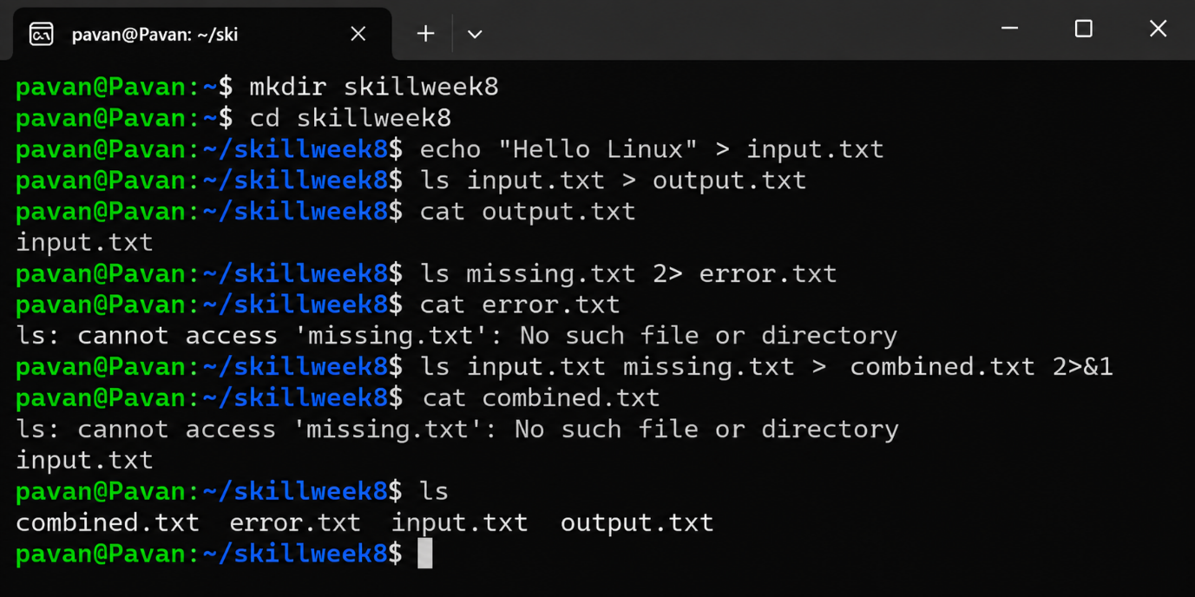
Observation
Standard output and standard error were redirected into separate files. Using 2>&1, both streams were successfully combined into combined.txt.
Result
The combined redirection of standard output and standard error was successfully performed and verified.

Aim
To practice complex Linux commands by combining pipes (|) and redirection (>), understand their execution order, and verify the generated output.
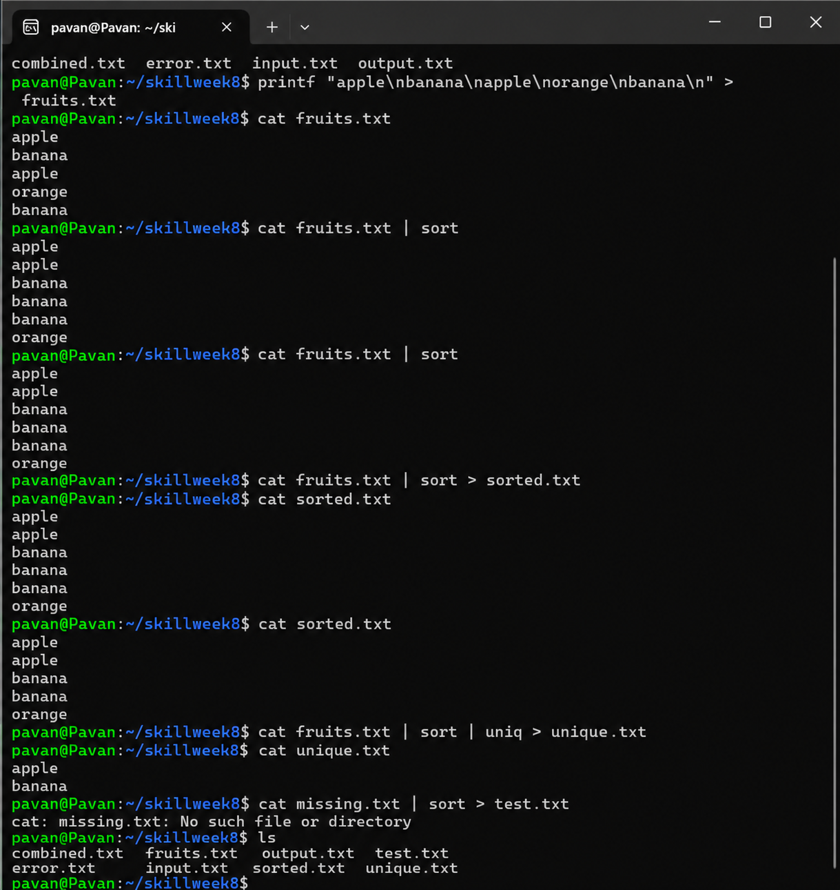
Observation
The pipe operator | passes the output of one command as input to the next command. The > operator saves the final command output into a file. Combining sort and uniq successfully produced sorted data without duplicate entries.
Result
Complex Linux commands using pipes and output redirection were successfully executed, verified, and tested with both valid and invalid input scenarios.

Aim
To learn how to run processes in the background using &, check background jobs, and monitor their execution in Linux.
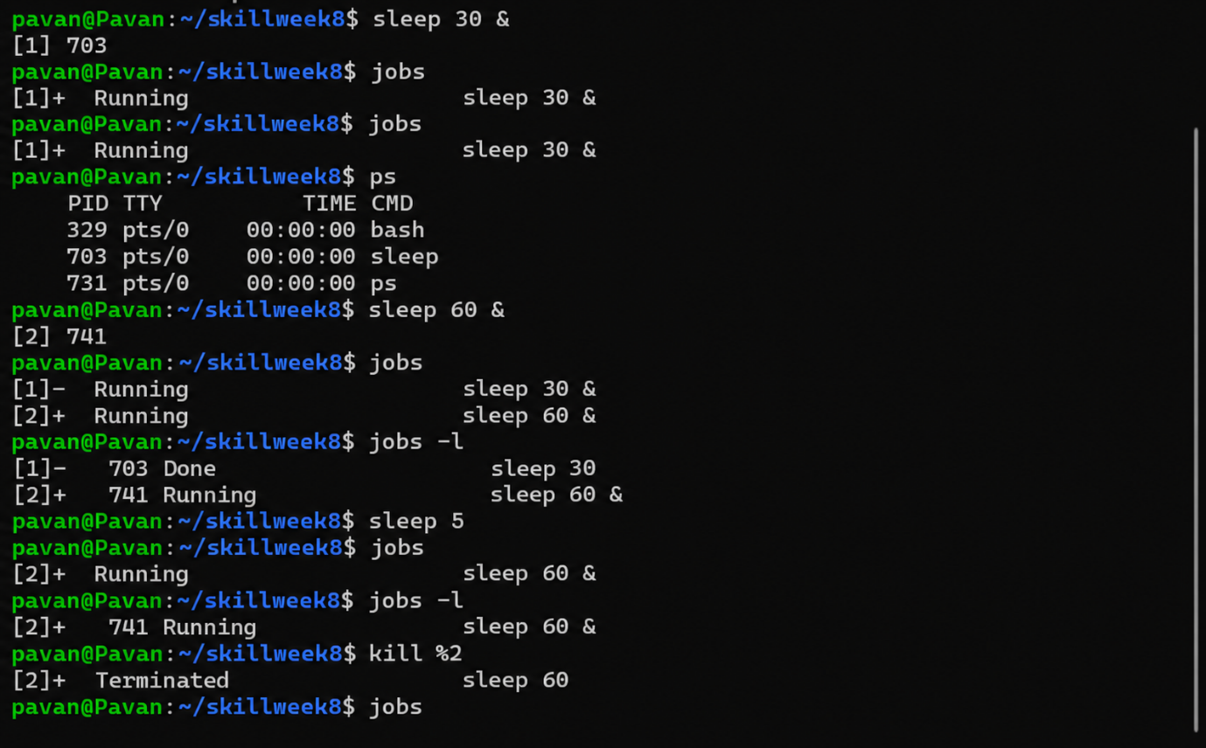
Observation
The & operator allows a command to run as a background process, so the terminal prompt returns immediately. The jobs command displays active background jobs, while jobs -l provides their process IDs and status.
Result
Background processes were successfully launched, monitored, and terminated using Linux job-control commands.

Aim
To learn how to create and manage a job table in Linux, monitor process states, identify process IDs and process groups, and verify completed or running jobs.
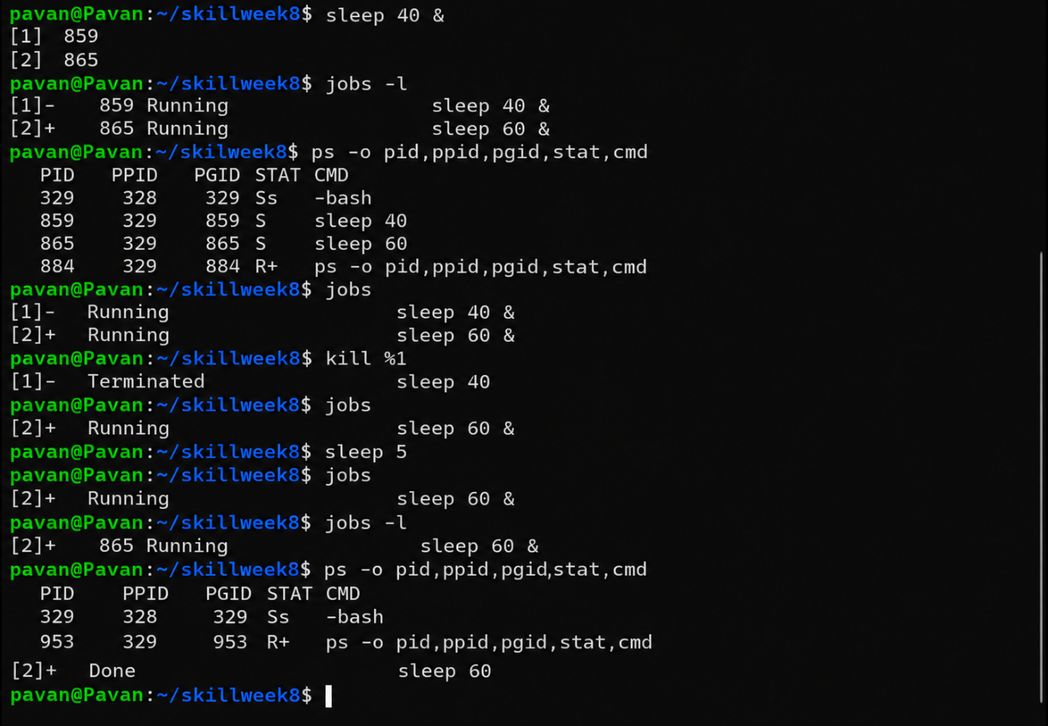
Observation
The jobs command displays background jobs and their status. The ps command provides process IDs, parent process IDs, process group IDs, and process states. Completed or terminated jobs are removed from the active job list.
Result
The job table and process states were successfully created, monitored, updated, and verified using Linux job-control and process-management commands.

